AIAA @ UCSD 1st General Body Meeting
2 October 2007

Welcome to AIAA
Congratulations on taking your first step towards your engineering career! Your interest in complementing your academic back- ground with your involvement in a national professional organization prepares you to make astounding engineering contributions in the near future.

Right now is the best time to explore and engage yourself in aerospace engineering endeavors. The country’s constant need to fortify national security, the increasing feasibility of space tourism, and the greater desire to mobilize people in the air call for innovative developments from you, the engineer of tomorrow.

You definitely have the skills and abilities to meet this calling. The AIAA@UCSD board is here to help you along the way. We are composed of an enthused, dynamic group with varied interests and backgrounds. We are working hard to develop programs to help your career really get off the ground. These programs will lead you to discover abounding opportunities for a career in aeronautics and astronautics; equip you with the technical and social skills to thrive in an engineering environment; and maintain the confidence and reassurance to excel.

Have an excellent year and good luck on your journey in developing your fulfilling aerospace career! Let us know how we can help you begin your aerospace endeavors.

Irene Chan
AIAA@UCSD Chair
__________________________________________________________
Student Projects

▪ Design, Build, Fly This AIAA-sponsored project involves engineering students working together to design, build, and fly a remote controlled aircraft. The design parameters and missions that the plane needs to complete change yearly. Some of the challenges include carrying 7 pound payloads in random configurations and keeping the wingspan under a certain length. Contact: Professor Kosmatka, jkosmatka@ucsd.edu

▪ AUVSI The mission of the UCSD AUVSI Team is to raise interest and give students experience with unmanned technology. Currently the team is involved with the annual AUVSI UAV Student Competition. It calls for a vehicle capable of autonomous flight to navigate to specified locations and to utilize an array of onboard payload sensors to locate and assess a series of man- made objects prior to returning to the launch point for landing. The UCSD team’s first entry (June 2006) into the AUVSI UAV Challenge yielded a very respectable 5th place overall finish. Contact: Karthik Balakrishnan, karthik@ucsd.edu (continued on back)

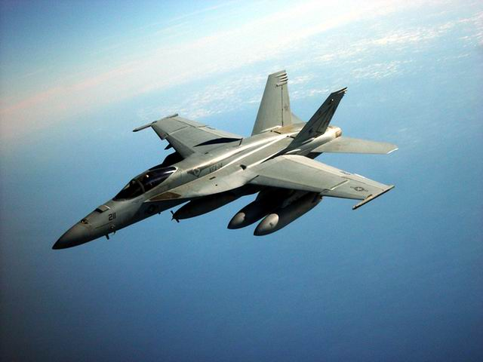

The Board

Chair: Irene Chan
ichan@ucsd.edu

Vice Chair, Programming:
Andrea Qualm
aqualm@ucsd.edu

Vice Chair, Fundraising:
Morgan Machado
mrmachad@ucsd.edu

Vice Chair, Membership:
Brian Preedanon
bpreedan@ucsd.edu

Vice Chair, Publicity:
Julia Stalder
jstalder@ucsd.edu

Treasurer: Tim Havard
timwillhav@gmail.com

Secretary/Webmaster:
Jacqueline Yu
jay002@ucds.edu

TESC Representatives:
Gabriel Hribik
ghribik@ucsd.edu

Derek Peterson
d3peters@ucsd.edu

Graduate Liaison:
Barry Hawkins
bghawkin@ucsd.edu

Student Projects (continued)

▪ Rocket Project The UCSD Hybrid Rocket team was established in 2006 by a group of aerospace, mechanical, and other engineering students to increase their knowledge of modern rocketry as well as to bring pride to the UCSD engineering program through participation in a hybrid rocketry competition. This year we aim to enter a competition being held by the Experimental Sounding Rocket Association (ESRA) in June. Contact: Samina Bhatia, sabhatia@ucsd.edu

Upcoming Events/News!

*Edwards AFB Information Session
Tuesday, October 9th 7:00pm - 8:00pm
EBU-III (CSE Building room 1202)

Miramar Airshow/BBQ
Saturday, October 13, 2007

Rocket Project Exhibit
Friday, October 19, 2007

Jet Propulsion Laboratory (JPL) Information Session
http://www.jpl.nasa.gov
October 23, 2007 7:30pm - 9:00pm
Horizon Room-Career Services Center
RSVP at PortTriton (https://ucsd-csm.symplicity.com/students)

General Atomics Fusion Generator Field Trip
Friday, October 26, 2007 2:00-3:30pm

Industry Panel
Tuesday, October 30, 2007

Transforming Space Conference
Monday, November 5 – Thursday, November 8, 2007
Sheraton Gateway Hotel near the Los Angeles Airport
Speakers include: Gen. Kevin Chilton (Air Force Space Command Commander), Shana Dale (NASA Deputy Administrator), and Elon Musk (CEO/CTO of SpaceX and founder of PayPal)
Register at www.californiaspaceauthority.org/conference2007

Lockheed Martin Information Session
http://www.lmco.com
Tuesday, November 6, 2007 5:00pm - 6:30pm
Horizon Room-Career Services Center

AIAA Undergraduate/Graduate Scholarship Program
$2000 Scholarship for the 2008-09 year
Register: http://aiaa.org/content.cfm?pageid=211
Application Deadline: January 31, 2008
CONTACT US! Email: aiaa@ucsd.edu Web: http://aiaa.ucsd.edu

